Missionaries and Cannibals
Aim
To solve the Missionaries and Cannibals problem using Python by safely transporting all missionaries and cannibals across the river without ever allowing cannibals to outnumber missionaries on either bank.
Objective
- To understand the Missionaries and Cannibals problem.
- To implement a Python solution.
- To ensure all safety constraints are satisfied.
- To find a valid sequence of moves from the initial state to the goal state.
Algorithm
- Start.
- Represent the initial state as (3 Missionaries, 3 Cannibals, Left Bank).
- Represent the goal state as (0 Missionaries, 0 Cannibals, Right Bank).
- Define all possible boat moves.
- Check whether each generated state is valid.
- Move the boat between banks.
- Continue exploring valid states until the goal is reached.
- Display the solution path.
- Stop.
Code:
print("=" * 60)
print(" ARTIFICIAL INTELLIGENCE LAB")
print(" Experiment: Missionaries and Cannibals")
print(" Name : Vinnarasu R")
print(" Reg No : 192411040")
print("=" * 60)

from collections import deque

q = deque([((3, 3, 0), [])])
moves = [(1, 0), (2, 0), (0, 1), (0, 2), (1, 1)]
seen = set()

while q:
(m, c, b), path = q.popleft()

if (m, c, b) in seen:
continue

seen.add((m, c, b))

if (m, c, b) == (0, 0, 1):
print("\nSolution Path:")
for state in path + [(m, c, b)]:
print(state)
break

for x, y in moves:
nm = m - x if b == 0 else m + x
nc = c - y if b == 0 else c + y

if 0 <= nm <= 3 and 0 <= nc <= 3:
if (nm == 0 or nm >= nc) and (3 - nm == 0 or 3 - nm >= 3 - nc):
q.append(((nm, nc, 1 - b), path + [(m, c, b)]))
Output:
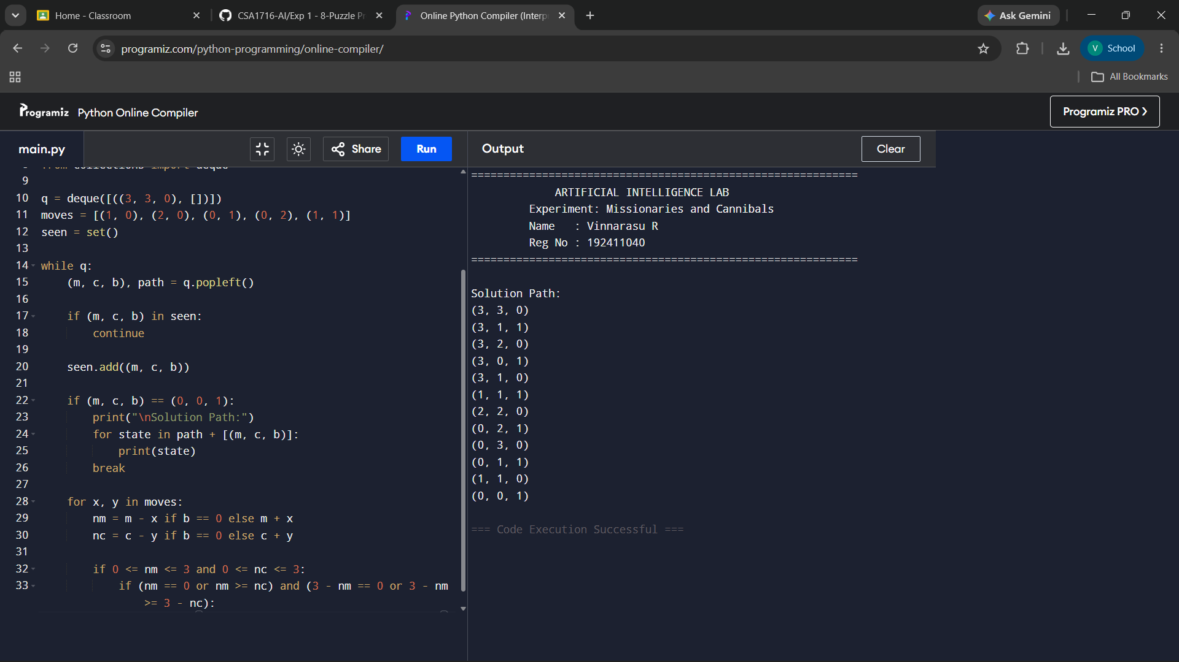
Result:
The Missionaries and Cannibals problem was successfully solved using Python. The program found a valid sequence of moves that safely transported all three missionaries and three cannibals across the river while satisfying all safety constraints.

